**17CS3116R – ENTERPRISE PROGRAMMING**

**PROJECT BASED REPORT**

**ON**

**PERMISSION APPROVAL SYSTEM**

***submitted in partial fulfillment of the requirement for the award of the degree of***

**BACHELOR OF TECHNOLOGY**

**In**

**COMPUTER SCIENCE AND ENGINNERING**

**By**

K. Rajesh (170030511)

M. Lalith Sri Kaashyap (170030699)

M. J. V. S. Prakash (170030852)

M.V.S. Pavan Kalyan (170030860)

Under the Esteemed Guidance of

**Mr. SK. MD Gouse*M.Tech***

**Assistant Professor**



**DEPARTMENT OF COMPUTER SCIENCE AND ENGINEERING**

**K L (Deemed to be) University**

Green Fields, Vaddeswaram, Guntur District – 522 502

**(2019-2020)**

**K L (Deemed to be) University**

**DEPARTMENT OF COMPUTER SCIENCE AND ENGINEERING**



**CERTIFICATE**

This is certify that the project based report entitled **“PERMISSION APPROVAL SYSTEM”** is a bonafide work done and submitted by **K. Rajesh (170030511), M. Lalith Sri Kaashyap (170030699), M.J.V.S. Prakash (170030852), M.V.S. Pavan Kalyan (170030860)** in partial fulfillment of the requirements for the award of the degree of **BACHELOR OF TECHNOLOGY** in Department of Computer Science Engineering, K L (Deemed to be University), Guntur District during the academic year **2019-2020**.

**Mr. SK.MD GOUSE Mr. V. HARI KIRAN**

**FACULTY INCHARGE HEAD OF THE DEPARTMENT**

DEPARTMENT OF CSE DEPARTMENT OF CSE K L (Deemed to be University) K L (Deemed to be University)

**EXTERNAL EXAMINER**

**K L (Deemed to be) University**

**DEPARTMENT OF COMPUTER SCIENCE AND ENGINEERING**



**DECLARATION**

This is certify that the project based report entitled **“PERMISSION APPROVAL SYSTEM”** is a bonafide work done and submitted by **K. Rajesh (170030511), M. Lalith Sri Kaashyap (170030699), M.J.V.S. Prakash (170030852), M.V.S. Pavan Kalyan (170030860)** in partial fulfillment of the requirements for the award of the degree of **BACHELOR OF TECHNOLOGY** in Department of Computer Science Engineering, K L (Deemed to be University), Guntur District during the academic year **2019-2020**.

|  |  |
| --- | --- |
| K. Rajesh | 170030511 |
| M. Kaashyap | 170030699 |
| M.Prakash | 170030852 |
| M. Pavan Kalyan | 170030860 |

**ACKNOWLEDGEMENT**

The success in this project would not have been possible but for the timely help and guidance rendered by many people. Our sincere thanks to all those who has assisted us in one way or the other for the completion of my project.

           Our greatest appreciation to our guide **Mr. SK. MD Gouse**, Assistant Professor, Department of Computer Science and Engineering which cannot be expressed in words for his tremendous support, encouragement and guidance for this project.

           We express our gratitude to **Mr. V. Hari Kiran,** Head of the Department for Computer Science and Engineering for providing us with adequate facilities, ways and means by which we are able to complete this project.

We thank all the members of teaching and non-teaching staff members, and also who have assisted us directly or indirectly for successful completion of this project.

Finally, we sincerely thank my friends and classmates for their kind help and co-operation during our work.

**K. Rajesh(170030511)**

**M.Kaashyap(170030699)**

**M. Prakash(170030852)**

**M.PavanKalyan(170030860)**

**CONTENTS**

|  |  |  |
| --- | --- | --- |
| **Chapter No.** | **Title** | **Page No.** |
| 1 | ABSTRACT | 6 |
| 2 | METHODOLOGY (Modules Description) | 7 |
| 3 | BLOCK DIAGRAM | 9 |
| 4 | SOFTWARE REQUIREMENTS | 10 |
| 5 | IMPLEMENTATION (Source Code) | 12 |
| 6 | OUTPUT SCREENSHOTS | 44 |
| 7 | CONCLUSION AND FUTURE SCOPE | 48 |
| 8 | REFERENCES | 49 |

1. **ABSTRACT**

Permission Management System is the process of making Permissions online. Employees of a company can access Permission management system portal to raise a request for permission with unique ID and will submit it to a leader of employees. Leader will decide if the permission is to be granted. When a leader rejects the permission, a message is to be displayed in employee dashboard when employee logins. If the leader approves the letter it will be forwarded to Manager with unique ID generated at the time of raising the permission. Either manager approves or rejects, the response will be displayed on the dashboards of both leader and manager.

**2.METHODOLOGY**

There are 3 modules

1.Employee module

2.Leader module

3.Manager module

**EMPLOYEE MODULE:**

When an employee login with valid credentials, there will be dashboard showcasing employee Name, Employee Image and the buttons as described below.

**PREVIOUS PERMISSIONS:**

Employee can access previous Permissions, by clicking this button. There will be a list of permissions with unique ID generated at the time of raising request.

**RAISE PERMISSION:**

Employees can raise a request, when they click this button. They will be given text areas, where they can type the request information.When they click the submit button, letter with unique ID will be submitted to Leader. The raised request should be displayed in the previous Permissions list.

**LEADER MODULE:**

When an employee login through leader button with valid credentials, he/she can see the list of Pending Permissions applied by the employees working under him.

**PENDING PERMISSIONS:**

When an employee submitted a permission in employee module leader can view those permissions in his dashboard where a drop-down list will show the list of employees who raised the permissions.

Leader can click on any permission so that leader he can view, approve or delete permission. When a leader rejected the request, there will be a status change of permission in previous permission list in employee module. On the other hand, when leader approved the raised permission, the letter with unique ID will be submitted to Manager.

**MANAGER MODULE:**

**PREVIOUS PERMISSIONS:**

Here Manager can view a list of employees who applied for permissions under which a list of permissions applied by an employee.

**PENDING PERMISSIONS:**

When an employee login through Manager button with valid credentials, he/she can see the list of Pending Permissions applied by the Employees working under designated leaders. Manager can see both the employee who raised the permission and the leader of employee. Manager will validate the Permission and Unique ID generated at the time of raising a permission. Whatever the response of Manager, it will be redirected to both leader and Employee **“PERMISSION WITH UNIQUE-ID XXXXXXXX IS APPROVED/REJECTED”** and the status of permission in both Leader module and Employee Module need to be updated corresponding to the response of Manager.

**3.BLOCK DIAGRAM**

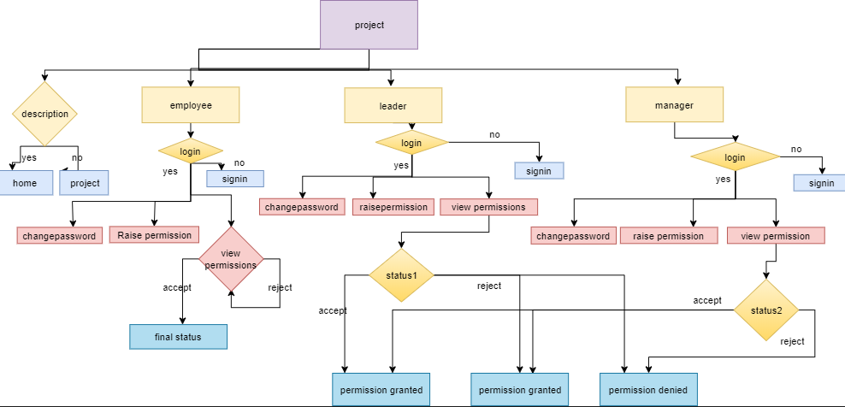

**4.SOFTWARE REQUIREMENTS**

**FRONT END**

**HTML-**Hypertext Markup Language (HTML) is the standard [markup language](https://en.wikipedia.org/wiki/Markup_language) for documents designed to be displayed in a [web browser](https://en.wikipedia.org/wiki/Web_browser). It can be assisted by technologies such as [Cascading Style Sheets](https://en.wikipedia.org/wiki/Cascading_Style_Sheets) (CSS) and [scripting languages](https://en.wikipedia.org/wiki/Scripting_language) such as [JavaScript](https://en.wikipedia.org/wiki/JavaScript).

**CSS-** Cascading Style Sheets (CSS) is a [style sheet language](https://en.wikipedia.org/wiki/Style_sheet_language) used for describing the [presentation](https://en.wikipedia.org/wiki/Presentation_semantics) of a document written in a [markup language](https://en.wikipedia.org/wiki/Markup_language) like [HTML](https://en.wikipedia.org/wiki/HTML).CSS is designed to enable the separation of presentation and content, including [layout](https://en.wikipedia.org/wiki/Page_layout), [colors](https://en.wikipedia.org/wiki/Color), and [fonts](https://en.wikipedia.org/wiki/Typeface).

**JAVASCRIPT-**JavaScriptwas initiallycreated to“make web pages alive”.

The programs in this language are called scripts. They can be written right in a web page’s HTML and run automatically as the page loads.Scripts are provided and executed as plain text. They don’t need special preparation or compilation to run.

**MIDDLEWARE**

**JSP-** JavaServer Pages (JSP) is a Java standard technology that enables you to write dynamic, data-driven pages for your Java web applications. JSP is built on top of the [Java Servlet specification](https://www.javaworld.com/article/3313114/learn-java/what-is-a-java-servlet-request-handling-for-java-web-applications.html). The two technologies typically work together, especially in older Java web applications. From a coding perspective, the most obvious difference between them is that with servlets you write Java code and then embed client-side markup (like HTML) into that code, whereas with JSP you start with the client-side script or markup, then embed JSP tags to connect your page to the Java backend.

**BACKEND**

**ORACLE-**Oracle is a relational database management system. It is widely used in enterprise applications. Our **Oracle tutorial** includes all topics of **Oracle** database such as insert record, update record, delete record, select record, create table, drop table etc.

# Oracle database is a relational database management system. It is known as Oracle database, OracleDB or simply Oracle. It is produced and marketed by Oracle Corporation.

Oracle database is the first database designed for enterprise grid computing. The enterprise grid computing provides the most flexible and cost effective way to manage information and applications.

**IDE**

# **ECLIPSE** -Eclipse is an integrated development environment (IDE) for Java and other programming languages like C, C++, PHP, and Ruby etc. Development environment provided by Eclipse includes the Eclipse Java development tools (JDT) for Java, Eclipse CDT for C/C++, and Eclipse PDT for PHP, among others.

Eclipse is an integrated development environment (IDE) used in computer programming. It contains a base workspace and an extensible plug-in system for customizing the environment. ... It can also be used to develop documents with LaTeX (via a TeXlipse plug-in) and packages for the software Mathematica.

**WEB SERVER**

# **APACHE TOMCAT**-The Apache Tomcat® software is an open source implementation of the Java Servlet, JavaServer Pages, Java Expression Language and Java WebSocket technologies. ... Apache Tomcat software powers numerous large-scale, mission-critical web applications across a diverse range of industries and organizations.

**DEVELOPMENT KIT**

# **JDK-7**-The **Java** Platform, Standard Edition **7** Development Kit (JDK 7) is a feature release of the **Java** platform. It contains new features and enhancements in many functional areas. See the following links to release information about enhancements, changes, bugs, installation, runtime deployment, and documentation.

**5.IMPLEMENTATION**

**Index.html**

<!DOCTYPE html>

<html lang="en">

<head>

<title>Phoenix</title>

<meta charset="utf-8">

<meta name="viewport" content="width=device-width, initial-scale=1, shrink-to-fit=no">

<link href="https://fonts.googleapis.com/css?family=Abril+Fatface:400,400i|Roboto+Mono&display=swap" rel="stylesheet">

<link rel="stylesheet" href="css/animate.css">

<link rel="stylesheet" href="css/owl.carousel.min.css">

<link rel="stylesheet" href="css/jquery.fancybox.min.css">

<link rel="stylesheet" href="fonts/ionicons/css/ionicons.min.css">

<link rel="stylesheet" href="fonts/fontawesome/css/font-awesome.min.css">

<link rel="stylesheet" href="fonts/flaticon/font/flaticon.css">

<link rel="stylesheet" href="css/aos.css">

<link rel="stylesheet"

href="https://cdnjs.cloudflare.com/ajax/libs/simple-line-icons/2.4.1/css/simple-line-icons.css">

<!-- Theme Style -->

<link rel="stylesheet" href="css/style.css">

</head>

<body>

<header role="banner">

<nav class="navbar navbar-expand-lg bg-dark">

<div class="container-fluid">

<a class="navbar-brand " href="index.html">PHOENIX</a>

<img src="images/image.ico" alt="AVATAR" width="200" height="100">

<button class="navbar-toggler" type="button" data-toggle="collapse" data-target="#navbarsExample05"

aria-controls="navbarsExample05" aria-expanded="false" aria-label="Toggle navigation">

<span class="navbar-toggler-icon"></span>

</button>

<div class="collapse navbar-collapse" id="navbarsExample05">

<ul class="navbar-nav pl-md-5 ml-auto">

<li class="nav-item">

<a class="nav-link active" href="index.html">Home</a>

</li>

<li class="nav-item">

<a class="nav-link" href="about.html">About</a>

</li>

<li class="nav-item">

<a class="nav-link" href="contact.html">Contact</a>

</li>

<li class="nav-item">

<a class="nav-link" href="joinus/home1.html">Join Us</a>

</li>

</ul>

</div>

</div>

</nav>

</header>

<!-- END header -->

<div class="slider-item overlay" data-stellar-background-ratio="0.5"

style="background-image: url('images/hero_2.jpg');">

<div class="container">

<div class="row slider-text align-items-center justify-content-center">

<div class="col-lg-12 text-center col-sm-12">

<h1 class="mb-4" data-aos="fade-up" data-aos-delay="100">We are phoenix we turn dreams to reality.</h1>

</div>

</div>

</div>

</div>

<footer class="site-footer" role="contentinfo">

<div class="container">

<div class="row mb-5">

<div class="col-md-4 mb-5">

<h3 class="mb-4">About Us</h3>

<p class="mb-5">Pheonix is a creator of worlds, committed to enriching players' lives with original and memorable gaming experiences.</p>

</div>

<div class="col-md-3 ml-auto">

<h3 class="mb-4">Navigation</h3>

<ul class="list-unstyled footer-link">

<li><a href="index.html">Home</a></li>

<li><a href="about.html">About</a></li>

<li><a href="contact.html">Contact</a></li>

<li><a href="joinus/home1.html">Join Us</a></li>

</ul>

</div>

</div>

</div>

<div class="row">

<div class="col-12 text-md-center text-left">

<p>

<!-- Link back to Colorlib can't be removed. Template is licensed under CC BY 3.0. -->

Copyright &copy;<script>document.write(new Date().getFullYear());</script> All rights reserved

<!-- Link back to Colorlib can't be removed. Template is licensed under CC BY 3.0. -->

</p>

</div>

</div>

</div>

</footer>

<!-- END footer -->

<!-- loader -->

<div id="loader" class="show fullscreen"><svg class="circular" width="48px" height="48px">

<circle class="path-bg" cx="24" cy="24" r="22" fill="none" stroke-width="4" stroke="#eeeeee" />

<circle class="path" cx="24" cy="24" r="22" fill="none" stroke-width="4" stroke-miterlimit="10"

stroke="#ffc107" /></svg></div>

<script src="js/jquery-3.2.1.min.js"></script>

<script src="js/jquery-migrate-3.0.1.min.js"></script>

<script src="js/popper.min.js"></script>

<script src="js/bootstrap.min.js"></script>

<script src="js/owl.carousel.min.js"></script>

<script src="js/jquery.waypoints.min.js"></script>

<script src="js/jquery.fancybox.min.js"></script>

<script src="js/jquery.stellar.min.js"></script>

<script src="js/aos.js"></script>

<script src="js/main.js"></script>

</body>

</html>

**Signup.html**

<!DOCTYPE html>

<html lang="en">

<head>

<title>Login V13</title>

<meta charset="UTF-8">

<meta name="viewport" content="width=device-width, initial-scale=1">

<!--===============================================================================================-->

<link rel="icon" type="image/png" href="images/icons/favicon.ico"/>

<!--===============================================================================================-->

<link rel="stylesheet" type="text/css" href="vendor/bootstrap/css/bootstrap.min.css">

<!--===============================================================================================-->

<link rel="stylesheet" type="text/css" href="fonts/font-awesome-4.7.0/css/font-awesome.min.css">

<!--===============================================================================================-->

<link rel="stylesheet" type="text/css" href="fonts/Linearicons-Free-v1.0.0/icon-font.min.css">

<!--===============================================================================================-->

<link rel="stylesheet" type="text/css" href="fonts/iconic/css/material-design-iconic-font.min.css">

<!--===============================================================================================-->

<link rel="stylesheet" type="text/css" href="vendor/animate/animate.css">

<!--===============================================================================================-->

<link rel="stylesheet" type="text/css" href="vendor/css-hamburgers/hamburgers.min.css">

<!--===============================================================================================-->

<link rel="stylesheet" type="text/css" href="vendor/animsition/css/animsition.min.css">

<!--===============================================================================================-->

<link rel="stylesheet" type="text/css" href="vendor/select2/select2.min.css">

<!--===============================================================================================-->

<link rel="stylesheet" type="text/css" href="vendor/daterangepicker/daterangepicker.css">

<!--===============================================================================================-->

<link rel="stylesheet" type="text/css" href="css/util.css">

<link rel="stylesheet" type="text/css" href="css/main.css">

<!--===============================================================================================-->

<script>

function validateForm() {

var x = document.forms["myForm"]["empid"].value;

var a = document.forms["myForm"]["fname"].value;

var b = document.forms["myForm"]["lname"].value;

var c = document.forms["myForm"]["gender"].value;

var d = document.forms["myForm"]["uname"].value;

var e = document.forms["myForm"]["email"].value;

var f = document.forms["myForm"]["password"].value;

var g = document.forms["myForm"]["repeat-pass"].value;

var h = document.forms["myForm"]["mobile"].value;

var i = document.forms["myForm"]["address"].value;

if (x == "") {

alert("EmployeeId must be filled out");

return false;

}

else if (a == "") {

alert("FirstName must be filled out");

return false;

}

else if (b == "") {

alert("LastName must be filled out");

return false;

}

else if (c == "") {

alert("Gender must be filled out");

return false;

}

else if (d == "") {

alert("UserName must be filled out");

return false;

}

else if (e == "") {

alert("Email must be filled out");

return false;

}

else if (f == "") {

alert("Password must be filled out");

return false;

}

else if (g == "") {

alert("Confirm Password must be filled out");

return false;

}

else if (h == "") {

alert("Mobile must be filled out");

return false;

}

else if (i == "") {

alert("Address must be filled out");

return false;

}

if (f != g) {

alert("Password And Confirm Password didnot match");

return false;

}

else

return true;

}

</script>

</head>

<body style="background-color: #999999;">

<div class="limiter">

<div class="container-login100">

<div class="login100-more" style="background-image: url('images/bg-01.jpg');"></div>

<div class="wrap-login100 p-l-50 p-r-50 p-t-72 p-b-50">

<form name = "myForm" class="login100-form validate-form" action ="sign.jsp" onsubmit="return validateForm()">

<span class="login100-form-title p-b-59">

Sign Up

</span>

<div class="wrap-input100 validate-input" data-validate="ID is required" >

<span class="label-input100">Employee Id</span>

<input class="input100" type="text" name="empid" placeholder="Enter Your ID">

<span class="focus-input100"></span>

</div>

<div class="wrap-input100 validate-input" data-validate="Name is required" >

<span class="label-input100">First Name</span>

<input class="input100" type="text" name="fname" placeholder="Enter Your FirstName">

<span class="focus-input100"></span>

</div>

<div class="wrap-input100 validate-input" data-validate="Name is required" >

<span class="label-input100">Last Name</span>

<input class="input100" type="text" name="lname" placeholder="Enter Your LastName">

<span class="focus-input100"></span>

</div>

<div class="wrap-input100 validate-input" data-validate="Gender is required">

<span class="label-input100">Gender</span>

<select class="input100" type="text" name="gender" placeholder="Enter Your Gender">

<option value="Male">Male</option>

<option value="Female">Female</option>

<option value="Other">Other</option>

</select>

<span class="focus-input100"></span>

</div>

<div class="wrap-input100 validate-input" data-validate="Username is required" >

<span class="label-input100">Username</span>

<input class="input100" type="text" name="uname" placeholder="Enter Your Username">

<span class="focus-input100"></span>

</div>

<div class="wrap-input100 validate-input" data-validate = "Valid email is required: ex@gmail.com" >

<span class="label-input100">Email</span>

<input class="input100" type="text" name="email" placeholder="Enter Your Email addess">

<span class="focus-input100"></span>

</div>

<div class="wrap-input100 validate-input" data-validate = "Password is required" >

<span class="label-input100">Password</span>

<input class="input100" type="text" name="password" placeholder="*************">

<span class="focus-input100"></span>

</div>

<div class="wrap-input100 validate-input" data-validate = "Confirm Password is required">

<span class="label-input100">Confirm Password</span>

<input class="input100" type="text" name="repeat-pass" placeholder="*************">

<span class="focus-input100"></span>

</div>

<div class="wrap-input100 validate-input" data-validate="Mobile No is required" >

<span class="label-input100">Mobile No</span>

<input class="input100" type="text" name="mobile" placeholder="Enter Your MobileNo">

<span class="focus-input100"></span>

</div>

<div class="wrap-input100 validate-input" data-validate="Address is required" >

<span class="label-input100">Address</span>

<input class="input100" type="text" name="address" placeholder="Enter Your Address">

<span class="focus-input100"></span>

</div>

<div class="flex-m w-full p-b-33">

<div class="contact100-form-checkbox">

<input class="input-checkbox100" id="ckb1" type="checkbox" name="remember-me">

<label class="label-checkbox100" for="ckb1">

<span class="txt1">

I agree to the

<a href="#" class="txt2 hov1">

Terms of User

</a>

</span>

</label>

</div>

</div>

<div class="container-login100-form-btn">

<div class="wrap-login100-form-btn">

<div class="login100-form-bgbtn"></div>

<button class="login100-form-btn">

Sign Up

</button>

</div>

</div>

</form>

</div>

</div>

</div>

<!--===============================================================================================-->

<script src="vendor/jquery/jquery-3.2.1.min.js"></script>

<!--===============================================================================================-->

<script src="vendor/animsition/js/animsition.min.js"></script>

<!--===============================================================================================-->

<script src="vendor/bootstrap/js/popper.js"></script>

<script src="vendor/bootstrap/js/bootstrap.min.js"></script>

<!--===============================================================================================-->

<script src="vendor/select2/select2.min.js"></script>

<!--===============================================================================================-->

<script src="vendor/daterangepicker/moment.min.js"></script>

<script src="vendor/daterangepicker/daterangepicker.js"></script>

<!--===============================================================================================-->

<script src="vendor/countdowntime/countdowntime.js"></script>

<!--===============================================================================================-->

<script src="js/main.js"></script>

</body>

</html>

**Manager.html**

<!DOCTYPE html>

<html>

<head>

<meta charset="ISO-8859-1">

<title>Manager profile</title>

<meta name="viewport" content="width=device-width, initial-scale=1, shrink-to-fit=no">

<link href="https://fonts.googleapis.com/css?family=Abril+Fatface:400,400i|Roboto+Mono&display=swap" rel="stylesheet">

<link rel="stylesheet" href="css/animate.css">

<link rel="stylesheet" href="css/owl.carousel.min.css">

<link rel="stylesheet" href="css/jquery.fancybox.min.css">

<link rel="stylesheet" href="fonts/ionicons/css/ionicons.min.css">

<link rel="stylesheet" href="fonts/fontawesome/css/font-awesome.min.css">

<link rel="stylesheet" href="fonts/flaticon/font/flaticon.css">

<link rel="stylesheet" href="css/aos.css">

<link rel="stylesheet"

href="https://cdnjs.cloudflare.com/ajax/libs/simple-line-icons/2.4.1/css/simple-line-icons.css">

<!-- Theme Style -->

<link rel="stylesheet" href="css/style.css">

<script src='https://kit.fontawesome.com/a076d05399.js'></script>

</head>

<body>

<header role="banner">

<nav class="navbar navbar-expand-lg bg-dark">

<div class="container-fluid">

<a class="navbar-brand " href="index.html">PHEONIX</a>

<img src="images/image.ico" alt="AVATAR" width="200" height="100">

<button class="navbar-toggler" type="button" data-toggle="collapse" data-target="#navbarsExample05"

aria-controls="navbarsExample05" aria-expanded="false" aria-label="Toggle navigation">

<span class="navbar-toggler-icon"></span>

</button>

<div class="collapse navbar-collapse" id="navbarsExample05">

<ul class="navbar-nav pl-md-5 ml-auto">

<li class="nav-item">

<a class="nav-link" href="manager.html">Home</a>

</li>

<li class="nav-item">

<a class="nav-link" href="change.html">Change Password</a>

</li>

<li class="nav-item">

<a class="nav-link" href="">View Permission</a>

</li>

<li class="nav-item">

<a class="nav-link" href="../Login/login_pageM.html">logout</a>

</li>

</ul>

</div>

</div>

</nav>

</header>

<div class="slider-item overlay" data-stellar-background-ratio="0.5"

style="background-image: url('images/hero_2.jpg');">

<div class="container">

<div class="row slider-text align-items-center justify-content-center text-center">

<div class="col-lg-12 col-sm-12">

<h1 class="mb-4" data-aos="fade-up" data-aos-delay="">We are phoenix we turn dreams to reality.</h1>

</div>

</div>

</div>

</div>

<br>

<br>

<footer class="site-footer" role="contentinfo">

<div class="container">

<div class="row mb-5">

<div class="col-md-4 mb-5">

<h3 class="mb-4">About Us</h3>

<p class="mb-5">Pheonix is a creator of worlds, committed to enriching players' lives with original and memorable gaming experiences.</p>

</div>

<div class="col-md-3 ml-auto">

<h3 class="mb-4">Navigation</h3>

<ul class="list-unstyled footer-link">

<li><a href="index.html">Home</a></li>

<li><a href="change.html">Change Password</a></li>

<li><a href=".html">View Permission</a></li>

</ul>

</div>

</div>

</div>

<div class="row">

<div class="col-12 text-md-center text-left">

<p>

<!-- Link back to Colorlib can't be removed. Template is licensed under CC BY 3.0. -->

Copyright &copy;<script>document.write(new Date().getFullYear());</script> All rights reserved

<!-- Link back to Colorlib can't be removed. Template is licensed under CC BY 3.0. -->

</p>

</div>

</div>

</div>

</footer>

<div id="loader" class="show fullscreen"><svg class="circular" width="48px" height="48px">

<circle class="path-bg" cx="24" cy="24" r="22" fill="none" stroke-width="4" stroke="#eeeeee" />

<circle class="path" cx="24" cy="24" r="22" fill="none" stroke-width="4" stroke-miterlimit="10"

stroke="#ffc107" /></svg></div>

<script src="js/jquery-3.2.1.min.js"></script>

<script src="js/jquery-migrate-3.0.1.min.js"></script>

<script src="js/popper.min.js"></script>

<script src="js/bootstrap.min.js"></script>

<script src="js/owl.carousel.min.js"></script>

<script src="js/jquery.waypoints.min.js"></script>

<script src="js/jquery.fancybox.min.js"></script>

<script src="js/jquery.stellar.min.js"></script>

<script src="js/aos.js"></script>

<script src="js/main.js"></script>

</body>

</html>

**Leader.html**

<!DOCTYPE html>

<html>

<head>

<meta charset="ISO-8859-1">

<title>Leader profile</title>

<meta name="viewport" content="width=device-width, initial-scale=1, shrink-to-fit=no">

<link href="https://fonts.googleapis.com/css?family=Abril+Fatface:400,400i|Roboto+Mono&display=swap" rel="stylesheet">

<link rel="stylesheet" href="css/animate.css">

<link rel="stylesheet" href="css/owl.carousel.min.css">

<link rel="stylesheet" href="css/jquery.fancybox.min.css">

<link rel="stylesheet" href="fonts/ionicons/css/ionicons.min.css">

<link rel="stylesheet" href="fonts/fontawesome/css/font-awesome.min.css">

<link rel="stylesheet" href="fonts/flaticon/font/flaticon.css">

<link rel="stylesheet" href="css/aos.css">

<link rel="stylesheet"

href="https://cdnjs.cloudflare.com/ajax/libs/simple-line-icons/2.4.1/css/simple-line-icons.css">

<!-- Theme Style -->

<link rel="stylesheet" href="css/style.css">

<script src='https://kit.fontawesome.com/a076d05399.js'></script>

</head>

<body>

<header role="banner">

<nav class="navbar navbar-expand-lg bg-dark">

<div class="container-fluid">

<a class="navbar-brand " href="index.html">PHEONIX</a>

<img src="images/image.ico" alt="AVATAR" width="200" height="100">

<button class="navbar-toggler" type="button" data-toggle="collapse" data-target="#navbarsExample05"

aria-controls="navbarsExample05" aria-expanded="false" aria-label="Toggle navigation">

<span class="navbar-toggler-icon"></span>

</button>

<div class="collapse navbar-collapse" id="navbarsExample05">

<ul class="navbar-nav pl-md-5 ml-auto">

<li class="nav-item">

<a class="nav-link" href="leader.html">Home</a>

</li>

<li class="nav-item">

<a class="nav-link" href="../change/change1.html">Change Password</a>

</li>

<li class="nav-item">

<a class="nav-link" href="contact.html">View Permission</a>

</li>

<li class="nav-item">

<a class="nav-link" href="../Login/login_pageL.html">logout</a>

</li>

</ul>

</div>

</div>

</nav>

</header>

<div class="slider-item overlay" data-stellar-background-ratio="0.5"

style="background-image: url('images/hero_2.jpg');">

<div class="container">

<div class="row slider-text align-items-center justify-content-center text-center">

<div class="col-lg-12 col-sm-12">

<h1 class="mb-4" data-aos="fade-up" data-aos-delay="">We are phoenix we turn dreams to reality.</h1>

</div>

</div>

</div>

</div>

<br>

<br>

<footer class="site-footer" role="contentinfo">

<div class="container">

<div class="row mb-5">

<div class="col-md-4 mb-5">

<h3 class="mb-4">About Us</h3>

<p class="mb-5">Pheonix is a creator of worlds, committed to enriching players' lives with original and memorable gaming experiences.</p>

</div>

<div class="col-md-3 ml-auto">

<h3 class="mb-4">Navigation</h3>

<ul class="list-unstyled footer-link">

<li><a href="leader.html">Home</a></li>

<li><a href="../change/change1.html">Change Password</a></li>

<li><a href=".html">View Permission</a></li>

</ul>

</div>

</div>

</div>

<div class="row">

<div class="col-12 text-md-center text-left">

<p>

<!-- Link back to Colorlib can't be removed. Template is licensed under CC BY 3.0. -->

Copyright &copy;<script>document.write(new Date().getFullYear());</script> All rights reserved

<!-- Link back to Colorlib can't be removed. Template is licensed under CC BY 3.0. -->

</p>

</div>

</div>

</div>

</footer>

<div id="loader" class="show fullscreen"><svg class="circular" width="48px" height="48px">

<circle class="path-bg" cx="24" cy="24" r="22" fill="none" stroke-width="4" stroke="#eeeeee" />

<circle class="path" cx="24" cy="24" r="22" fill="none" stroke-width="4" stroke-miterlimit="10"

stroke="#ffc107" /></svg></div>

<script src="js/jquery-3.2.1.min.js"></script>

<script src="js/jquery-migrate-3.0.1.min.js"></script>

<script src="js/popper.min.js"></script>

<script src="js/bootstrap.min.js"></script>

<script src="js/owl.carousel.min.js"></script>

<script src="js/jquery.waypoints.min.js"></script>

<script src="js/jquery.fancybox.min.js"></script>

<script src="js/jquery.stellar.min.js"></script>

<script src="js/aos.js"></script>

<script src="js/main.js"></script>

</body>

</html>

**emplogin.jsp**

<%@page import="java.sql.ResultSet"%>

<%@page import="java.sql.PreparedStatement"%>

<%@page import="java.sql.DriverManager"%>

<%@page import="java.sql.Connection"%>

<%@ page language="java" contentType="text/html; charset=ISO-8859-1"

pageEncoding="ISO-8859-1"%>

<%

String uname = request.getParameter("username");

String password = request.getParameter("password");

try{

Class.forName("oracle.jdbc.driver.OracleDriver");

Connection con = DriverManager.getConnection("jdbc:oracle:thin:@localhost:1521:xe","system","tiger");

String vsql = "select * from employee where uname=? and password=?";

PreparedStatement pstmt = con.prepareStatement(vsql);

pstmt.setString(5, uname);

pstmt.setString(7, password);

ResultSet rs= pstmt.executeQuery();

if(rs.next()){

%>

<%

response.sendRedirect("profile.html");

}

con.close();

}catch(Exception e)

{

out.println("Unable to connect to Database.");

}

%>

**Changepwd.jsp**

<!DOCTYPE html>

<html>

<head>

<meta charset="ISO-8859-1">

<title>Employee Form</title>

<script type="text/javascript">

function validateForm() {

var x = document.forms["myForm"]["empid"].value;

var f = document.forms["myForm"]["password"].value;

var g = document.forms["myForm"]["cpwd"].value;

if (x == "") {

alert("EmployeeId must be filled out");

return false;

}

if (f != g) {

alert("Password And Confirm Password didnot match");

return false;

}

else

return true;

}

</script>

</head>

<body bgcolor="yellow">

<form name="myForm" action="change.jsp" method="post" onsubmit="return validateForm()" >

<table align="center">

<tr>

<th colspan="2"><h2 align=center>Change Password Form</h2></th>

</tr>

<tr>

<td><b>Employee ID:</b></td>

<td><input type="text" name="empid"></td>

</tr>

<tr>

<td><b>New Password:</b></td>

<td><input type="text" name="password"></td>

</tr>

<tr>

<td><b>Confirm Password:</b></td>

<td><input type="text" name="cpwd"></td>

</tr>

<tr>

<td colspan=2 align="center"><input type="submit" value="Submit"/>

</tr>

</table>

</form>

</body>

</html>

**Permission.jsp**

<%@page import="java.sql.PreparedStatement"%>

<%@page import="java.sql.DriverManager"%>

<%@page import="java.sql.Connection"%>

<%@ page language="java" contentType="text/html; charset=ISO-8859-1"

pageEncoding="ISO-8859-1"

%>

<%

int pid = Integer.parseInt(request.getParameter("pid"));

String pcat = request.getParameter("pcat");

String sd = request.getParameter("sd");

String ed = request.getParameter("ed");

String dur = request.getParameter("dur");

String res = request.getParameter("res");

String st1 = "processing";

String st2 = "processing";

String fst = "processing";

try{

Class.forName("oracle.jdbc.driver.OracleDriver");

Connection con = DriverManager.getConnection("jdbc:oracle:thin:@localhost:1521:xe","system","tiger");

String vsql = "insert into permission values(?,?,?,?,?,?,?,?,?)";

PreparedStatement pstmt = con.prepareStatement(vsql);

pstmt.setInt(1, pid);

pstmt.setString(2, pcat);

pstmt.setString(3, sd);

pstmt.setString(4, ed);

pstmt.setString(5, dur);

pstmt.setString(6, res);

pstmt.setString(7, st1);

pstmt.setString(8, st2);

pstmt.setString(9, fst);

int i = pstmt.executeUpdate();

if(i !=0){

%>

<br>

<a align = "center"><h1>Request Sent Successfully</h1> </a>

<%

response.sendRedirect("profile.html");

}

con.close();

}catch(Exception e)

{

out.println("Unable to connect to Database.");

}

%>

**viewpermissions.jsp**

<%@ page import="java.sql.*" %>

<%

int pid =Integer.parseInt(request.getParameter("pid"));

try{

Class.forName("oracle.jdbc.driver.OracleDriver");

Connection con = null;

con = DriverManager.getConnection("jdbc:oracle:thin:@localhost:1521:xe", "system", "tiger");

System.out.println("Connection Established");

PreparedStatement pstmt = con.prepareStatement("select * from permission where pid=? ");

ResultSet rs = pstmt.executeQuery();

%>

<br>

<a align = "center"><h1>Permission Form </h1> </a>

<%

while(rs.next())

{ out.println("\n");

out.println("Permission Id: "+rs.getInt(1)+"\n"+"Permission Category: "+rs.getString(2)+"\n"+"Start Date: "+rs.getString(3)+"\n"+"End Date: "+rs.getString(4)+"\n"+"Duration: "+rs.getString(5)+"\n"+"Reason: "+rs.getString(6)+"\n"+"LeaderAcceptance: "+rs.getString(7)+"\n"+"ManagerAcceptance : "+rs.getString(8)+"\n"+"FinalStatus: "+rs.getString(9));

out.println("\n");

}

response.sendRedirect("profile.html");

}

catch(Exception e)

{

out.println(e);

}

%>

**LoginLead.html**

<!DOCTYPE html>

<html lang="en">

<head>

<title>PHEONIX</title>

<meta charset="UTF-8">

<meta name="viewport" content="width=device-width, initial-scale=1">

<!--===============================================================================================-->

<link rel="icon" type="image/png" href="images/icons/favicon.ico"/>

<!--===============================================================================================-->

<link rel="stylesheet" type="text/css" href="vendor/bootstrap/css/bootstrap.min.css">

<!--===============================================================================================-->

<link rel="stylesheet" type="text/css" href="fonts/font-awesome-4.7.0/css/font-awesome.min.css">

<!--===============================================================================================-->

<link rel="stylesheet" type="text/css" href="fonts/iconic/css/material-design-iconic-font.min.css">

<!--===============================================================================================-->

<link rel="stylesheet" type="text/css" href="vendor/animate/animate.css">

<!--===============================================================================================-->

<link rel="stylesheet" type="text/css" href="vendor/css-hamburgers/hamburgers.min.css">

<!--===============================================================================================-->

<link rel="stylesheet" type="text/css" href="vendor/animsition/css/animsition.min.css">

<!--===============================================================================================-->

<link rel="stylesheet" type="text/css" href="vendor/select2/select2.min.css">

<!--===============================================================================================-->

<link rel="stylesheet" type="text/css" href="vendor/daterangepicker/daterangepicker.css">

<!--===============================================================================================-->

<link rel="stylesheet" type="text/css" href="css/util.css">

<link rel="stylesheet" type="text/css" href="css/main.css">

<!--===============================================================================================-->

</head>

<body>

<div class="limiter">

<div class="container-login100" style="background-image: url('images/city.jpg');">

<div class="wrap-login100 p-l-55 p-r-55 p-t-65 p-b-54">

<form class="login100-form validate-form" action="loginlead.jsp" method="POST">

<span class="login100-form-avatar">

<img src="images/image.ico" alt="AVATAR">

</span>

<span class="login100-form-title p-b-49">

Login

</span>

<div class="wrap-input100 validate-input m-b-23" data-validate = "Username is reauired">

<span class="label-input100">Username</span>

<input class="input100" type="text" name="username" placeholder="Type your username">

<span class="focus-input100" data-symbol="&#xf206;"></span>

</div>

<div class="wrap-input100 validate-input" data-validate="Password is required">

<span class="label-input100">Password</span>

<input class="input100" type="password" name="pass" placeholder="Type your password">

<span class="focus-input100" data-symbol="&#xf190;"></span>

</div>

<div class="text-right p-t-8 p-b-31">

<a href="../change/change1.html">

Forgot password?

</a>

</div>

<div class="container-login100-form-btn">

<div class="wrap-login100-form-btn">

<div class="login100-form-bgbtn"></div>

<button class="login100-form-btn">

Login

</button>

</div>

</div>

</form>

</div>

</div>

</div>

<div id="dropDownSelect1"></div>

<!--===============================================================================================-->

<script src="vendor/jquery/jquery-3.2.1.min.js"></script>

<!--===============================================================================================-->

<script src="vendor/animsition/js/animsition.min.js"></script>

<!--===============================================================================================-->

<script src="vendor/bootstrap/js/popper.js"></script>

<script src="vendor/bootstrap/js/bootstrap.min.js"></script>

<!--===============================================================================================-->

<script src="vendor/select2/select2.min.js"></script>

<!--===============================================================================================-->

<script src="vendor/daterangepicker/moment.min.js"></script>

<script src="vendor/daterangepicker/daterangepicker.js"></script>

<!--===============================================================================================-->

<script src="vendor/countdowntime/countdowntime.js"></script>

<!--===============================================================================================-->

<script src="js/main.js"></script>

</body>

</html>

**6.OUTPUT SCREENSHOTS**

**Index.html**- homepage for permission management system

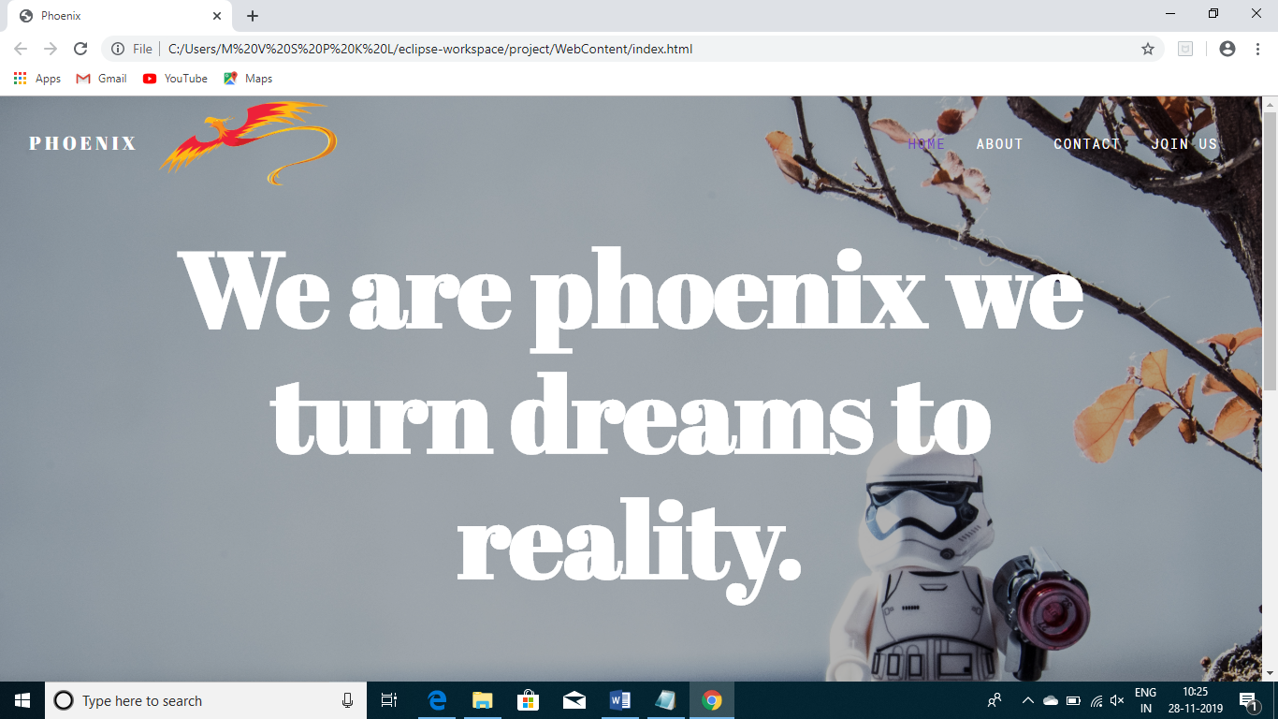

**joinus.html** -It involves the description of every module.

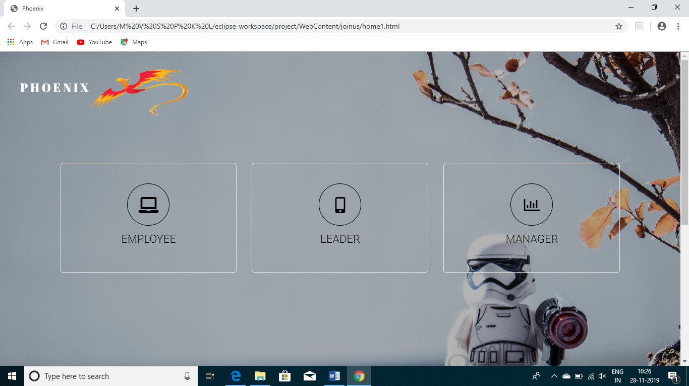

**Siginup.html-**In signin form ,employee registers if he/she doesn’t have a login page.

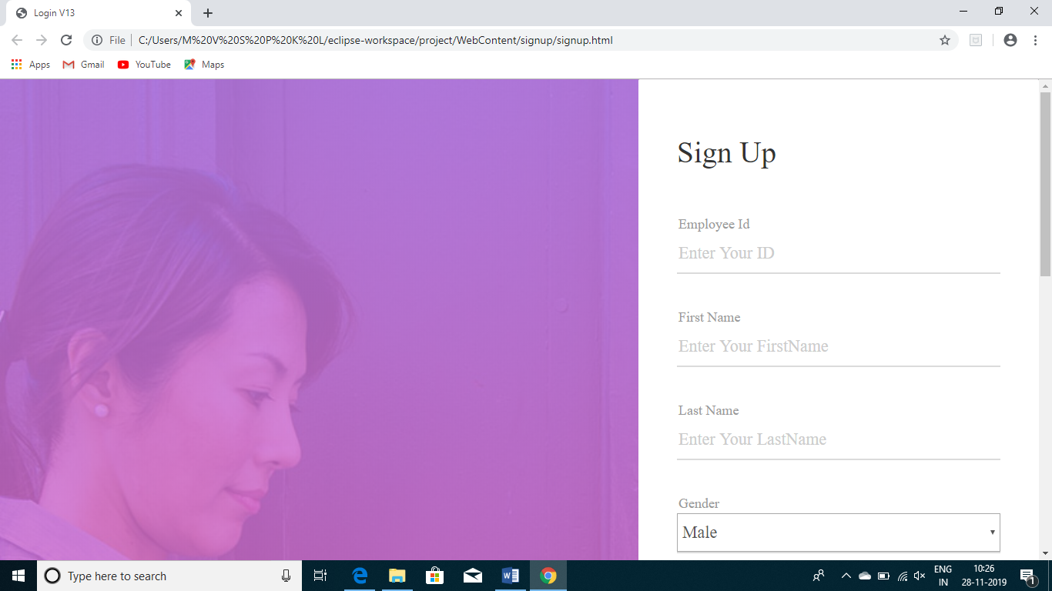

**Employee.html**-where employee login in employee login page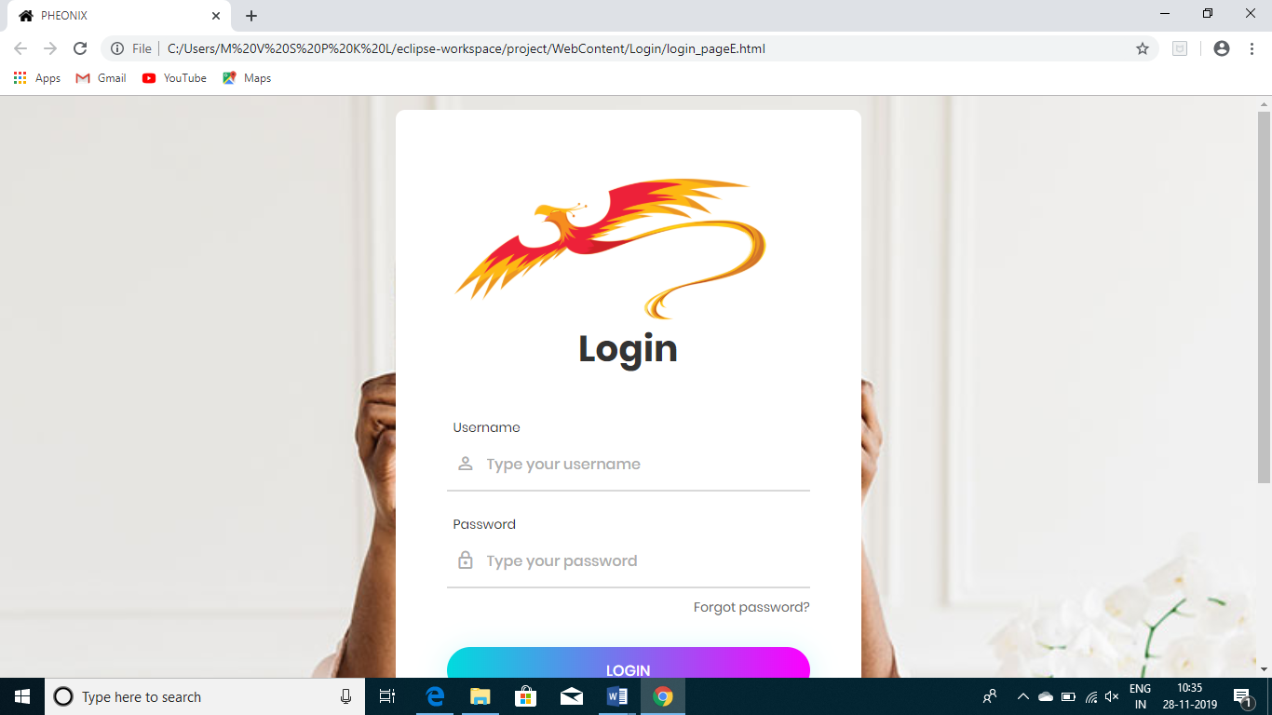

**profile.html**- It displays the employee home page where he/she can change password,raise permission,viewpermission and logout.

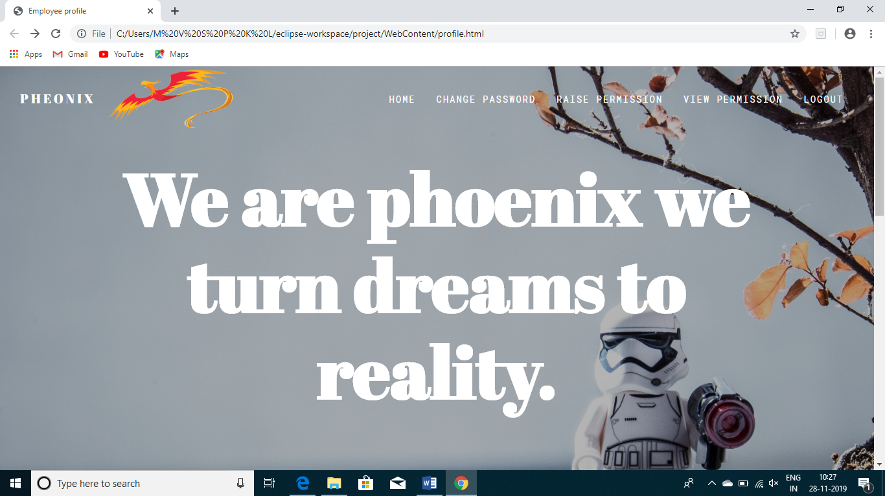

**raisepermission.html** -here,he/she can raise the permissions.

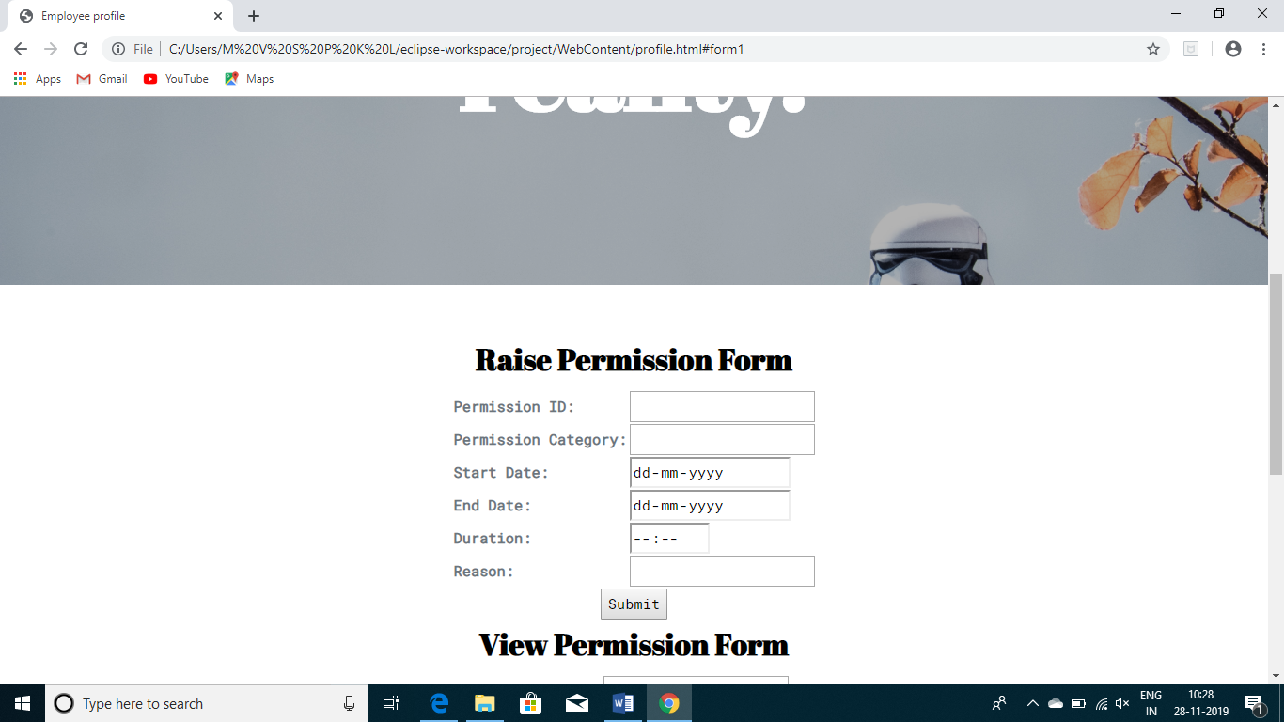

**changepwd.html** -employee,manager,leader can change the password in this password html form.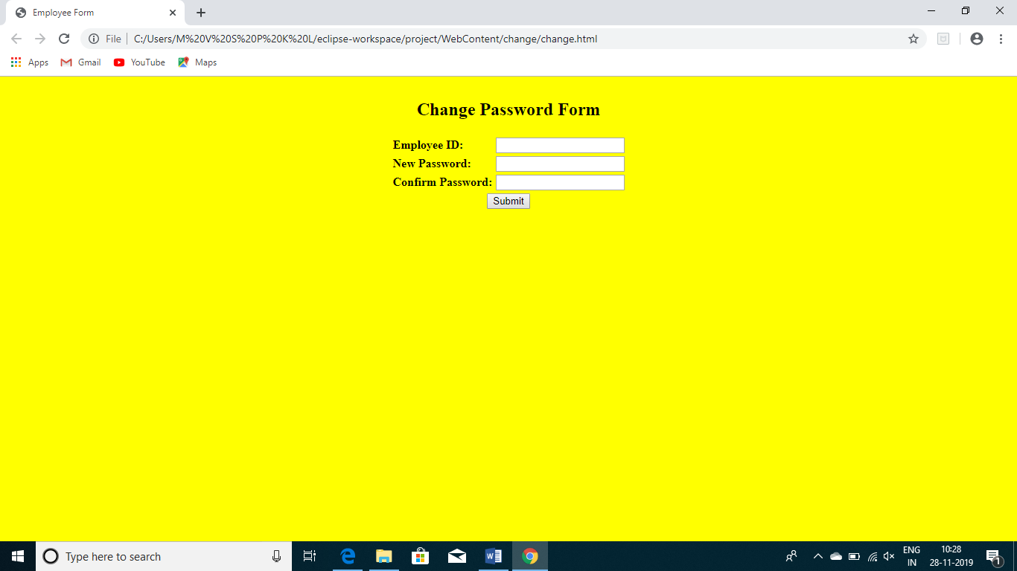

**Viewpermissions_l.jsp**-where he can see the status of permissions,either it is accepted or not.

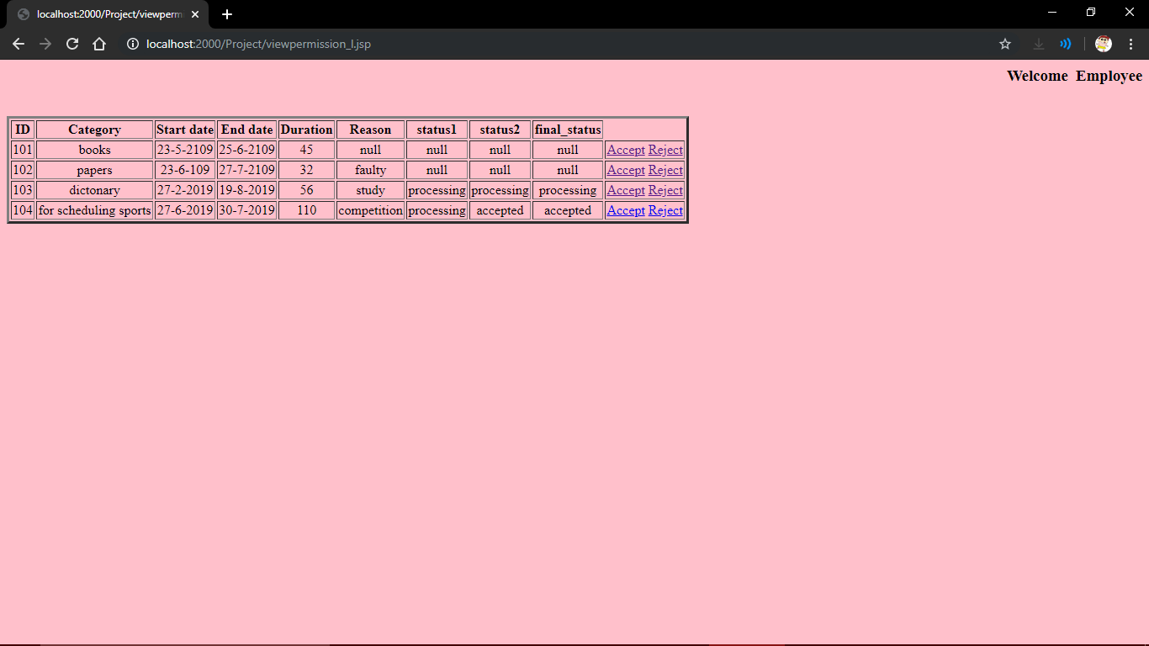

**7.CONCLUSION AND FUTURE SCOPE**

In this Project we have done the permission Generation the main aspective of

this project is generating permission As we all know that Permission Approval

is a major issue which is faced by many educational institutes, the main reason

for this is there is no automated system followed in any institute. To overcome

this practical problem and also to make the process easy we developed a

secured intranet application which is useful for that we have created three

modules Employee, Leader, Manager which makes the Approval process easy.

In future this project is used as the approval of permissions if we are having any

permission issues we can overcome them using this project the Approval can be

easy with this project the Permissions are generated easily.

**8. REFERENCES**

<https://web.iiit.ac.in/~nagarjuna.psug08/J2ME%20-%20The%20Complete%20Reference.pdf>

<https://wtf.tw/ref/duckett.pdf>

<https://www.tutorialspoint.com/javascript/javascript_tutorial.pdf>

<https://www.tutorialspoint.com/jsp/jsp_tutorial.pdf>